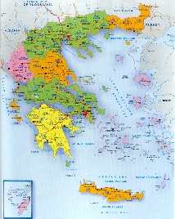
GREEK PROJECT DUE DATE 19 October 2018

2.Towns (5 -7 big towns)
History, population, important places etc
1.Map
3. Mountains, lakes, rivers
Greece
5 of each category or more if you want
Mythology, legends,
Information etc
4.Athens
Places, role, mythology, 5. Top islands (5-7)
History, other information etc

8.Touristic places (5-7)
6.Greek products, vegetables pictures, information, etc
Cheese, olives, famous 7.Animals, germination, climate, weather
products

